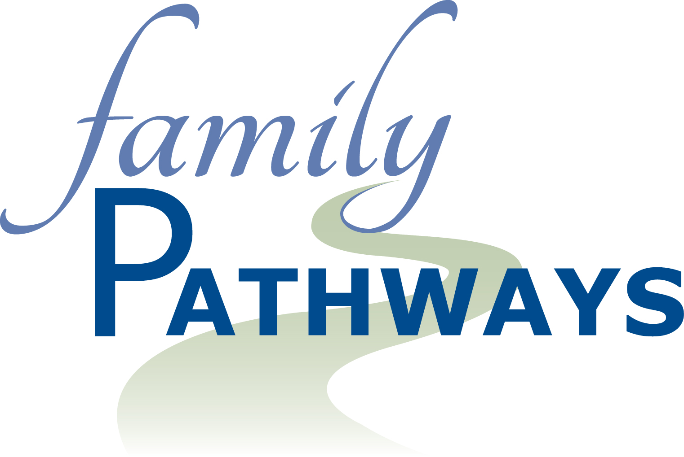
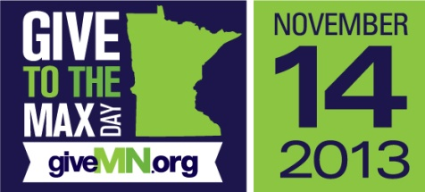

Give to the Max Day 2013
Dear Friend

Thank you for being a part of Family Pathways’ efforts to provide a safety net for the most vulnerable in our communities. In the next day or so you will be receiving our annual Thanksgiving Fund appeal in the mail. We want to let you know there is an alternative opportunity to support our organization.

November 14 is Minnesota’s Give to the Max Day. Every gift made on November 14 helps our chances of winning a $1,000 Golden Ticket! By partnering with GiveMN, an online giving website for Minnesota nonprofits, Family Pathways will have 25 chances to maximize your gift on Give to the Max Day!

Here’s the really exciting part: At the end of Give to the Max Day, one donation from across Minnesota will be randomly selected for a $10,000 Super-sized Golden Ticket!

The more gifts we receive online on November 14, the more our chances increase to receive that magical Golden Ticket! Just imagine if we could be able to provide every food shelf family with the fixings for a holiday meal.

Make your gift on November 14 by visiting GiveMN.org.

As you know, Family Pathways is changing lives every day by providing free programming with Food Shelves, Youth Services, and Senior Services.

You can visit GiveMN.org now and schedule your donation for November 14th or wait for your letter and use the remittance envelope that will be enclosed. However you choose to help we greatly appreciate your support.

Sincerely,

Rich Smith
Executive Director

