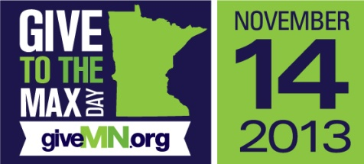

Give to the Max Day 2013
Industries, Incorporated

Friends - Thank you to being a part of the Industries, Incorporated team!

Each year generous supporters like you join us for the exciting 24 hour annual Give to the Max Day. Your support makes a meaningful difference in the lives of adults with disabilities.

As you know, Industries is changing lives every day by providing training and employment services for people with disabilities and other challenges which result in greater independence their communities.

On November 14, Minnesota’s Give to the Max Day, your $40 gift may help us win an extra $1,000 for our work in the community.

Every gift made on November 14 helps our chances of winning a $1,000 Golden Ticket! By partnering with GiveMN, an online giving website for Minnesota nonprofits, Industries will have 25 chances to maximize your gift on Give to the Max Day!

Here’s the really exciting part: At the end of Give to the Max Day, one donation from across Minnesota will be randomly selected for a $10,000 Super-sized Golden Ticket!

The more gifts we receive online on November 14, the more our chances increase to receive that magical Golden Ticket! Just imagine if we could buy a brand new vehicle to transport clients to and from work! What a dream for the people who rely on Industries’ to transport them to a job where meaningful work fits their needs and abilities. All gifts you make to Industries, Inc. on November 14 will increase our impact.

Make your gift on November 14 by visiting http://givemn.razoo.com/story/Industries

Follow us on Facebook at Industries, Inc. so you can share in the excitement of the giving day and remember to give on November 14!

Sincerely,

Michelle Thomas
Director of Sales and Marketing

P.S. Remember: At the end of Give to the Max Day, one donation from across Minnesota will be randomly selected for a $10,000 Super-sized Golden Ticket! Your gift helps increase our odds on November 14!

