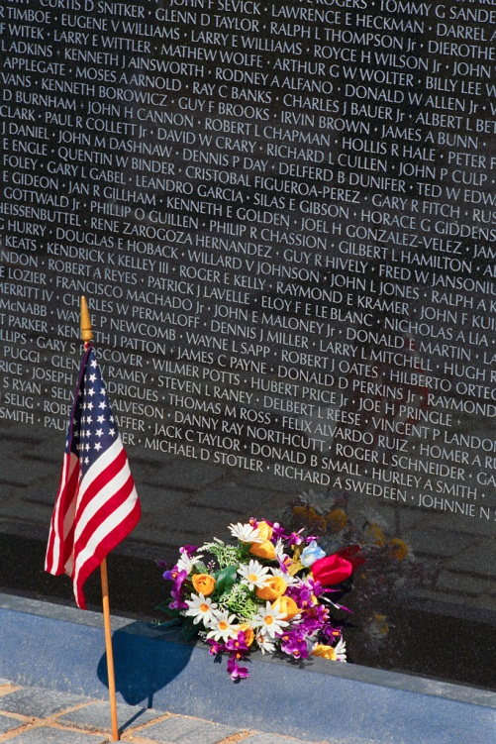

The Moving Wall
Coming To the Sandstone ‘Train Park’ - July 17-20

The half sized replica of the Vietnam War Memorial in Washington D.C. will be in Sandstone MN. Please be sure to stop and see it.

The opening ceremony is Thursday July 17th at 7pm.

Saturday July 19th at 11am - Dedication Ceremony.
The bagpipes will play at 10:30.
(Motorcyclists are planning a ride in honor of the Wall. The ride will start at Carlton and ride to Sandstone.)

The Moving Wall will be up 24 hours a day for viewing – beginning at 1pm July 17-20.

