Job Fair
October 20, 2014
3:00 – 7:00 p.m.
At the Minnesota Correctional Facility in Rush City

7600 - 525th St.
Rush City, Minnesota 55069

Located just off Hwy 61, north of Rush City.
Park in the visitors lot. Enter through main doors.

Come learn about how to start your exciting career in the Corrections field with the State of Minnesota!

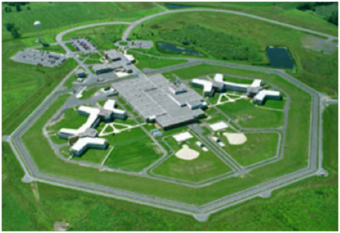
The Department of Corrections employs professionals in a variety of positions: Corrections Officers, Nurses, Facility Maintenance, Clinical Program Therapists, Teachers, and many other professions.
Corrections Officer trainee positions open for application from
October 20 to October 24, 2014.
  - We provide extensive training through our Department’s academy process. There you will gain the knowledge and skills to become a professional corrections employee.

