  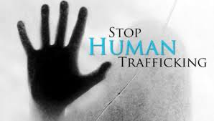
    - September 28, 2015
  5:00 Social - 5:30 Dinner & Program
  pINE rOOM - Freddie’s rESTAURANT
  810 HIGHWAY 65
  mORA, mn
  Human Trafficking
  Human Trafficking is everywhere – even in Mora.
  Our program will feature a panel of representatives from Lakes & Pines CAC and representatives from PAVSA (Program for Aid to Victims of Sexual Assault) from Duluth.
  Our area has a vulnerable population. Learn about risky behaviors and how we, as a community, can help prevent human trafficking.
  Sponsored by the Dala Business Women
  
  Human Trafficking generates $411 MILLION a DAY
  30% of teen runaways are lured into prostitution within 48 hours
  The Twin Cities is one of the nation’s Top 13 centers for child prostitution
  Educate yourself, this is happening in small towns across the country!
  Tickets $15
  meal & program
  For Reservations
  Call Linda Laitala
  612-889-5848 or email at
  Linda.Laitala@gmail.com

