SWEDISH ANCESTRY?
BIGGEST TV-SHOW IN SWEDEN NOW SEARCHING FOR AMERICANS WITH SWEDISH ANCESTORS!
Apply here: www.greatswedishadventure.com
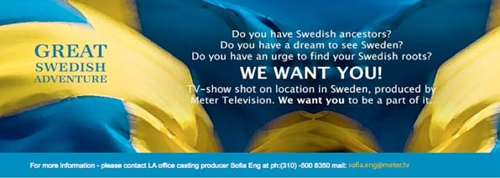

Meter Television is searching for Americans of Swedish descent to participate in one of the most popular and nominated show, “ALLT FÖR SVERIGE” (All for Sweden). 2 million Swedes (of a population of 9 millions) watched the season finale of season 5 in Dec 2015. Now the casting of season 6 has started.
Americans, accepted as participants, will travel to Sweden on an adventurous journey, learn about the culture and find out about their family who left for the USA. It’s all a part of a challenge with a SPECTACULAR prize; A FAMILY REUNION WITH THEIR LOST SWEDISH RELATIVES.
Go online and apply before the 14th of February 2016
WWW.GREATSWEDISHADVENTURE.COM

