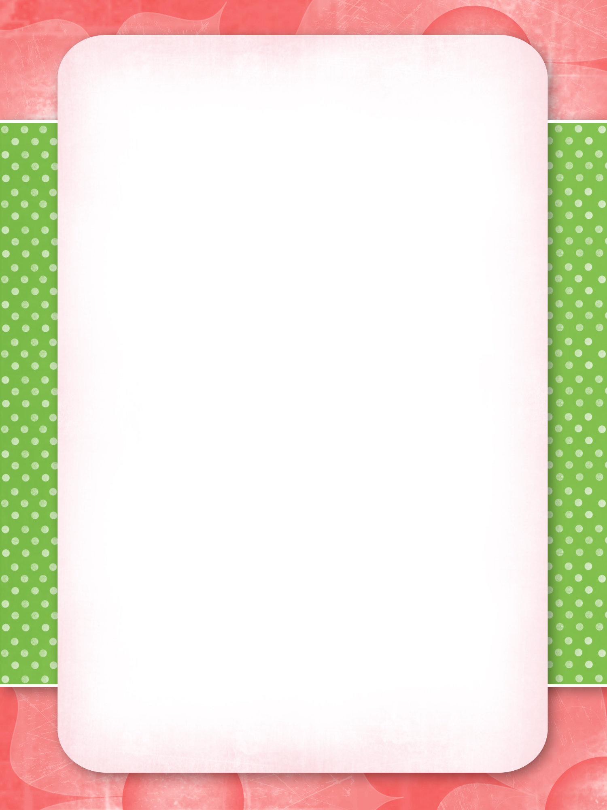

mARCH Special
Friday & Saturday
1 scoop
Mint chip ice cream
cone
94¢
Made Of mora
111 S Union St, Mora MN

